***Term Project***

**AI Assisted Fitness Tracking and Planning**

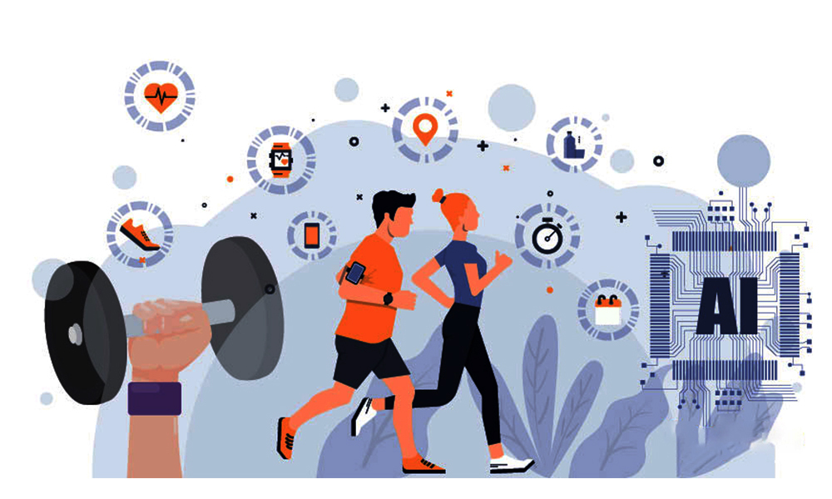

***By***

*Mufaddal Husain*

*Husain.mu@ortheastern.edu*

Submission Date: Nov 9th, 2023

EMGT5220: Engineering Project Management, Fall 2023

Northeastern University

Instructor: Prof. George Kontopidis

Table of Contents

1. Purpose 3

2. Objective 3

3. Scope 3

4. Funder/Investor 4

5. Critical Success Factors 4

6. Assumptions 4

7. Technical Approach 5

8. Organization 5

9. Project Plan 6

a. Work Breakdown Structure (WBS) 7

b. Resource Plan and Responsibilities (RACI) 8

c. Financial Plan 9

10

d. Pert Chart 10

e. Gantt Chart 12

10. Risk Assessment 12

11. Resource Allocation 15

12. Monitoring and Controlling 16

13. Summary 16

14. Appendix 17

a. MindMap 17

Figure 1. Org Chart 6

Figure 2. Magnified Project Org Chart 6

Figure 3. 3x3 Matrix 13

Figure 4. Mindmap 16

Figure 5. Sequential Diagram 17

Figure 6. Activity Diagram 18

Table 1. WBS 7

Table 2. RACI 8

Table 3. Finanial Plan 9

Table 4. 9

Table 5. Monthly Projectized Budget 10

Table 6. PERT Chart 1a 10

Table 7. PERT Chart 1b 11

Table 8. PERT Diagram with task duration 11

Table 9. Gantt Chart 12

Table 10. SWOT Analysis 13

Table 11. FMEA & RPN 14

**Revision History**

|  |  |
| --- | --- |
| 09/17/2023 | Draft #1: Project proposal and partner selection |
| 09/24/2023 | Draft#1a: Included Technical Approach and updated objective and scope. |
| 09/24/2023 | Draft #2: Included Mindmap, WBS, Financial Plan, Org Chart. |
| 11/09/2023 | Draft #3: Risk (SWOT, FMEA, RPN), PERT chart, Gantt chart, critical success factor and assumptions. |
| 11/26/2023 | Final Draft |

## Purpose

Even with an abundance of fitness tracking applications people are still in search of a fitness app which can assist them and tailor their meals and workout plans which suits them the best. The purpose of this project is to create an AI Assisted Fitness Planning and Tracking platform which can track the day-to-day activities of an individual and suggest personalized meals keeping a count of their nutrient’s intake. Furthermore, through analysis of their daily calories burn and past day’s record create workout plans. This app will collect all the data from the fitness wearable device worn by the individual and through their daily calories track suggest to them the workout plans along with the meal plans which will help them to maintain a balanced fitness schedule to achieve their fitness goals.

## Objective

This project aims to create an AI assisted fitness tracking and planning application. The primary objective is to create an AI assistant within the application for the individuals who are struggling to keep track of their diet and exercise plan. This application will be integrated with wearable devices to record tracked fitness data. The goal is to connect the recorded data with the AI technology to train it to generate personalized responses for the meals and workout plans. Ultimately this software aims to securely synchronize the real-time data from the wearable devices with the built-in AI assistant for accurate and faster response generation.

## Scope

We are planning to develop an AI Assisted Fitness Planning and Tracking platform for both mobile and browser interface. The scope of the project includes the following key tasks:

* Integration with Wearable Devices and Data Analysis: Integrate with fitness wearables to collect and analyze data, including activity levels, heart rate, calorie burn, and nutrient intake.
* Cloud services: Provide cloud service to perform the AI functionality and algorithms for accurate responses.
* Personalized Meal and Workout Planning: Implement an AI-driven module for personalized meal and workout plans based on user preferences, goals, and past performance. The system will adapt plans over time.
* User Feedback and Interaction: Develop a user-friendly interface for user interaction, feedback, and adjustments to plans, including chatbot or voice-based communication.
* Progress Tracking and Reporting: Design a dashboard for tracking and reporting fitness progress, enabling users to monitor their journey toward their goals.
* Security and Privacy Measures: Implement robust security measures to protect user data and ensure privacy compliance.
* Scalability, Testing, and Documentation: Ensure scalability for growth, conduct comprehensive testing (functionality, usability, performance), and create detailed documentation for system maintenance and user guidance.

## Funder/Investor

Since this application is based on a fitness wearable, Fitbit is a promising investor for this project. As it already has its fitness tracking application, however it has limited features and accessibility for users. Many users use other fitness applications and sync the tracking data with their Fitbit.

Fitbit can generate revenue by offering a subscription-based model for this AI integrated application. For the initial user adoption company can start by providing a freemium model to the existing Fitbit wearable users.

As of 2022, the number of registered Fitbit users is 120 million and 9 million Fitbits are sold[1]. If we assume 10% user adoption rate, i.e., 12 million users signup for the subscription-based model charged at $6/month, the projected revenue is $72 million per month. Which would be approximately $864 million annually.

## Critical Success Factors

1. User Engagement and Adoption:

The success of the platform relies on engaging users and encouraging consistent use. The adoption of AI-driven features, especially personalized meal and workout plans is crucial. A user-friendly interface and effective interaction play key roles in maintaining user engagement.

1. Integration with Wearable Devices:

Seamless integration with popular fitness wearables is critical for accurate data collection. The compatibility of the application with a variety of wearables ensures a broader user base and enhances the reliability of the collected fitness data.

1. Accuracy of AI Algorithms:

The accuracy of AI algorithms in analyzing fitness data and generating personalized plans is paramount. Continuous improvement of these algorithms, based on user feedback and evolving fitness trends, is essential for the effectiveness of the AI assistant.

## Assumptions

1. User Data Sharing and Wearable Usage:

Assumes users will consistently use wearables for tracking and willingly share personal health data. The reliability of AI-generated plans depends on users actively engaging with their wearables and providing accurate information.

1. Fitbit Partnership and Subscription Acceptance:

Assumes collaboration with Fitbit as a key investor and partner. The success of revenue projections relies on users, especially existing Fitbit users, accepting and subscribing to the premium features of the AI-integrated application.

1. Stability of Fitness Trends:

Assumes that fitness trends and guidelines remain stable. The effectiveness of AI algorithms is contingent on predictable patterns in fitness and nutrition, with minimal unexpected shifts impacting the accuracy of personalized plans.

## Technical Approach

1. Technology Stack Selection:

* Employ modern frontend technologies (React, Vue.js) for responsive, cross-platform user interfaces.
* Utilize scalable backend technologies (Python, Node.js) and frameworks (Django, Express.js) for robust functionality.
* Choose a reliable database system (MongoDB, PostgreSQL) for efficient data management.
* Implement AI and machine learning models (TensorFlow, PyTorch) to power personalized recommendations.
* Develop APIs and drivers for seamless integration with various fitness wearables.

2. User Experience (UX/UI):

* Craft intuitive, responsive UI/UX designs for web and mobile users.
* Incorporate real-time user feedback mechanisms for continuous improvement.

3. Data Collection and Analysis:

* Enable real-time data acquisition from wearable devices via wireless connections.
* Apply advanced algorithms for processing and analyzing fitness data, including biometrics and dietary information.

4. Personalized Planning Algorithms:

* Utilize machine learning models to generate personalized meal and workout plans.
* Implement adaptive algorithms that dynamically adjust plans based on user progress and goals.

5. User Interaction and Feedback:

* + Develop a conversational AI assistant to engage users, answer queries, and provide assistance.
  + Implement sentiment analysis for gauging user satisfaction and enhancing AI responses.

6. Security and Privacy:

* + Employ robust encryption protocols to secure data in transit and at rest.
  + Implement secure authentication and authorization mechanisms to safeguard user accounts.
  + Ensure compliance with relevant data privacy regulations.

## Organization

The organizational structure for the "AI Assisted Fitness Tracking and Planning" project under Fitbit is best described as a Matrix Organizational Structure, it is an example of composite organizations. It combines Fitbit's existing functional structure with cross-functional project teams focused on specific project tasks, allowing for the utilization of functional expertise while maintaining the flexibility and adaptability needed for the project's complexity.

* A diagram of a company

  Description automatically generatedA diagram of a company

  Description automatically generatedThis project team is composed of experts from various domains within the Fitbit organization.

Figure 1. Org Chart

Figure 2. Magnified Project Org Chart

* This is the team working for this project along with the project manager 1.
* In this team Engineering Manager, Software Development Functional Manager, Operational Manager will be incharge of their respective team members and who will be reporting to them.
* Engineering Manager, Software Development Functional Manager, Operational Manager will work for the Project Manager and report to their respective chief officers according to the heiarchy.

## Project Plan

This excel icon has all the worksheets for the below attached tables.

### Work Breakdown Structure (WBS)



Table 1. WBS

### Resource Plan and Responsibilities (RACI)



Table 2. RACI

### Financial Plan



Table 3. Finanial Plan

### 

Table 5. Monthly Projectized Budget

### Pert Chart

Table 6. PERT Chart 1a

Table 7. PERT Chart 1b

Table 8. PERT Diagram with task duration

### A graph of a project Description automatically generated with medium confidenceGantt Chart

Table 9. Gantt Chart

## Risk Assessment

1. **SWOT**

|  |  |
| --- | --- |
| **Strength**  S1 – Extensive resources available for the development of AI assistant  S2 – Access to the data from the Fitbit wearables currently in use.  S3 - Collaboration with Fitbit provides access to experts in multidisciplinary domains. | **Weakness**  W1 – Complexity in interacting the AI with the wearable device. W2 – Initial fitness data collection of all the possible workout variations to train the AI model. W3 – Possible security and privacy risks with real time synchronization of the data from the wearable. W4 – Maintaining the huge amount of user data from wearables and storing it in the cloud. |
| **Opportunities** O1 – Scalability of the project to different wearable devices.  O2 – Collaboration with other wearable companies to create a similar AI platform.  O3 - | **Threats**  T1 - Compatibility issues with the older versions of the wearables. T2 – (Limited market) Non-Fitbit wearable won’t be accessible with this model. T3 – Market competition from other fitness wearable companies. |

Table 10. SWOT Analysis

1. **A screenshot of a diagram

   Description automatically generatedRisk Matrix**

Figure 3. 3x3 Matrix

1. **FMEA & RPN**

Table 11. FMEA & RPN

1. **Risk Mitigation**

These are the risk mitigation for the SWOT analysis:

T1 - Compatibility issues with older wearables:

* + Regularly update firmware and software to ensure compatibility.

T2 - Limited market access for non-Fitbit wearables:

* + Explore partnerships and develop an open API for broader device integration.

T3 - Market competition from other fitness wearable companies:

* + Focus on continuous innovation, strategic partnerships, and effective marketing.

W1 - Complexity in AI interaction with the wearable:

* + Invest in a user-friendly interface, clear documentation, and gather user feedback.

W2 - Initial fitness data collection challenges:

* + Start with a core set of workout variations and regularly update the AI model.

W3 - Security and privacy risks with real-time data synchronization:

* + Implement robust encryption, communicate privacy policies, and provide user control.

W4 - Managing a large amount of user data in the cloud:

* + nvest in secure cloud infrastructure, implement data anonymization, and provide user control.

## Resource Allocation

This is the resource allocation for this project as per the WBS. No. of people involved in the project are more hence in the resource allocation I have considered the group of people who will be working on the same task for the specific duration.

## Monitoring and Controlling

These are the four monitoring and control metrics for the project:

1. Wearable Integration:

Monitoring: Regularly check data synchronization for compatibility and consistency between the app and various wearables.

Controlling: Address integration issues promptly, collaborate with manufacturers, and implement patches for seamless data flow.

1. AI Algorithm Performance:

Monitoring: Assess AI algorithm accuracy for personalized plans and track user satisfaction.

Controlling: Update algorithms based on feedback, conduct A/B testing, and adjust models for enhanced performance.

1. Security and Privacy Compliance:

Monitoring: Conduct regular audits to ensure effective data security measures.

Controlling: Implement updates to security protocols based on audits, ensuring compliance with evolving privacy regulations.

1. Technical Stack Performance:

Monitoring: Continuously monitor technology stack, server response times, and system scalability.

Controlling: Optimize server configurations, consider infrastructure scaling, and upgrade components for optimal performance based on monitoring insights.

## Summary

In summary, the "AI Assisted Fitness Tracking and Planning" project seeks to meet the growing demand for a user-friendly application that not only tracks daily activities but also provides personalized workout and meal plans. The collaboration with Fitbit as a potential investor enhances the project's viability. The application's success relies on factors like user engagement, seamless wearable integration, and accurate AI algorithms. Ultimately, the project aims to offer a comprehensive and intuitive solution, serving as a reliable companion for individuals striving to achieve their fitness goals.

## Appendix

### MindMap

Figure 4. Mindmap

1. **Sequential Diagram (Tool#1)**

Figure 5. Sequential Diagram

1. **Activity Diagram (Tool#2)**

Figure 6. Activity Diagram

References

1. * <https://www.statista.com/statistics/1327371/fitbit-registered-users/>

   [*https://chat.openai.com/c/ae5df010-65b8-4e5a-81b5-51b038345b03*](https://chat.openai.com/c/ae5df010-65b8-4e5a-81b5-51b038345b03)

   * [https://lucid.app/lucidspark/dbb389b7-d7f8-4a8c-9511-947df9580d53/edit?beaconFlowId=88B188F4DD75927A&invitationId=inv_96767c83-ff5b-4581-9c65-4d21720a5294&page=0_0#](https://lucid.app/lucidspark/dbb389b7-d7f8-4a8c-9511-947df9580d53/edit?beaconFlowId=88B188F4DD75927A&invitationId=inv_96767c83-ff5b-4581-9c65-4d21720a5294&page=0_0)
   * *Kontopidis, Prof. George. EMGT 5220 Course Slides, Northeastern University. Fall 2023.*
   * *Meredith, Jack R., et al. Project Management: A Strategic Managerial Approach. Tenth ed., John Wiley & Sons,  
     2021.*

  